1. **OBJECTIVES**

See the requirements document

1. **HARDWARE DESIGN**

See the PCB Artist schematic file

1. **SOFTWARE DESIGN**

No change in software design (call graphs and data flow graphs are the same as those provided in the lab manual).

1. **MEASUREMENT DATA**
   1. **Show the data and calculated resolution, range, precision and accuracy**

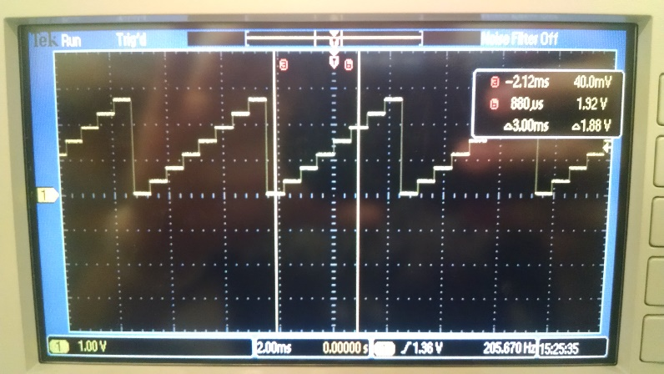

*Figure 1: Experimental measurement of the DAC output for 8 different digital inputs.*

*Our DAC’s actual output range is ~3 Volts (which makes sense because our*

*Vref was 1.5 Volts. Our DAC seemed to output less voltage than expected for*

*most of the tested values.*

|  |  |  |  |  |  |  |  |  |  |  |  |  |  |  |  |  |  |  |  |  |  |  |  |  |  |  |  |  |  |  |  |  |  |  |  |  |  |  |  |  |  |  |  |  |  |  |  |  |
| --- | --- | --- | --- | --- | --- | --- | --- | --- | --- | --- | --- | --- | --- | --- | --- | --- | --- | --- | --- | --- | --- | --- | --- | --- | --- | --- | --- | --- | --- | --- | --- | --- | --- | --- | --- | --- | --- | --- | --- | --- | --- | --- | --- | --- | --- | --- | --- | --- |
| |  |  |  |  |  |  |  |  |  |  | | --- | --- | --- | --- | --- | --- | --- | --- | --- | --- | | Digital Input | 0 | 512 | 1024 | 1536 | 2048 | 2560 | 3072 | 3584 | 4096 | | DAC Measured Output (V) | 0.07 | 0.43 | 0.81 | 1.19 | 1.57 | 1.93 | 2.3 | 2.68 | 3.05 | | Expected Output (V) | 0 | 0.4125 | 0.825 | 1.2375 | 1.65 | 2.0625 | 2.475 | 2.8875 | 3.3 | | Delta = Actual - Expected | 0.07 | 0.0175 | -0.015 | -0.0475 | -0.08 | -0.1325 | -0.175 | -0.2075 | -0.2467 | |  |  |  |  |  |  |  |  |
|  |  |  |  |  |  |  |  |  |
|  |  |  |  |  |  |  |  |  |
|  |  |  |  |  |  |  |  |  |

**Range:** 0 to 3.3V

**Precision:** 4096

**Resolution: (**range / precision) = 0.81mV

**Accuracy:**

**4.2 Show the experimental response of DAC including SNR**

**4.3 Show the results of the debugging profile**

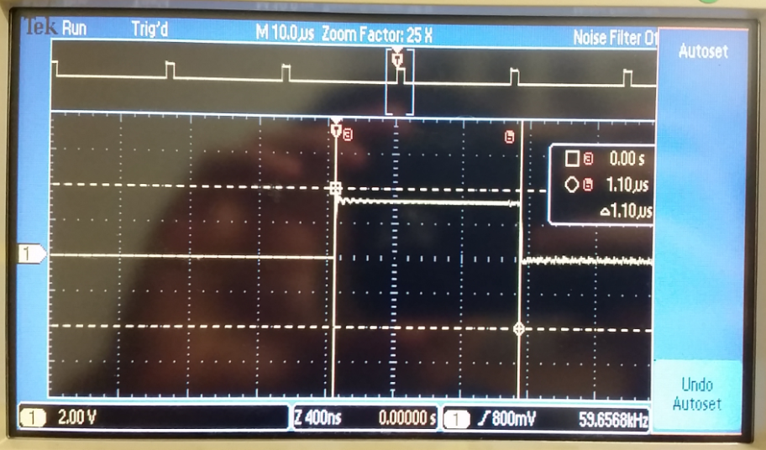

*Figure 1: This ISR shows the time it takes to output to the DAC (~1 microsecond)*

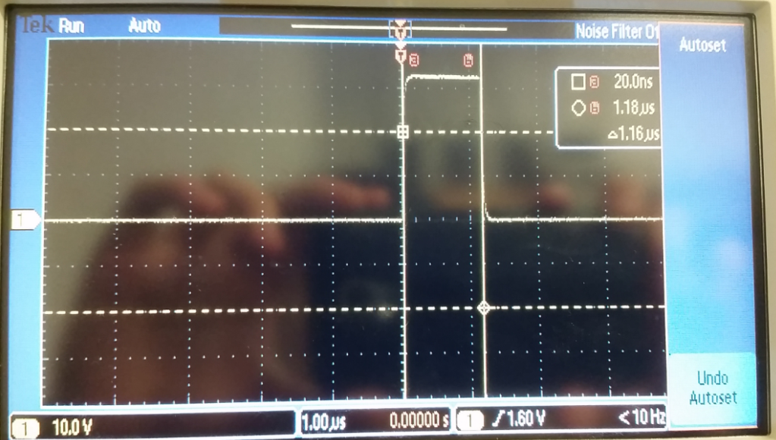

*Figure 2: This ISR shows the time it takes to change the tempo (~1.16 microseconds)*

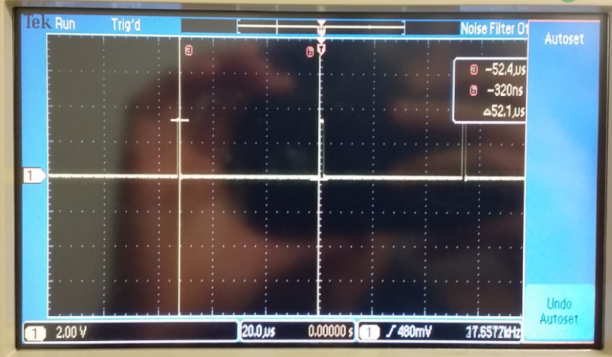

*Figure ###: The time between calls to DAC_Out() is about 52 microseconds and the time it takes to output a note is about 1 microsecond, so the percentage of time the processor is occupied by playing the song is ~1.92 %.*

**4.4 Measurements of current required to run the system, with and without the music playing**

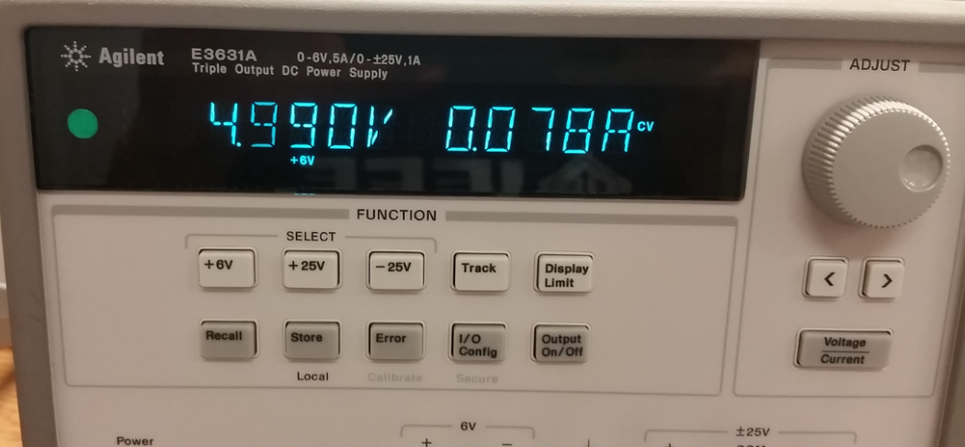

*Figure 3: about 78 mA was required to run the system* ***without*** *music playing*

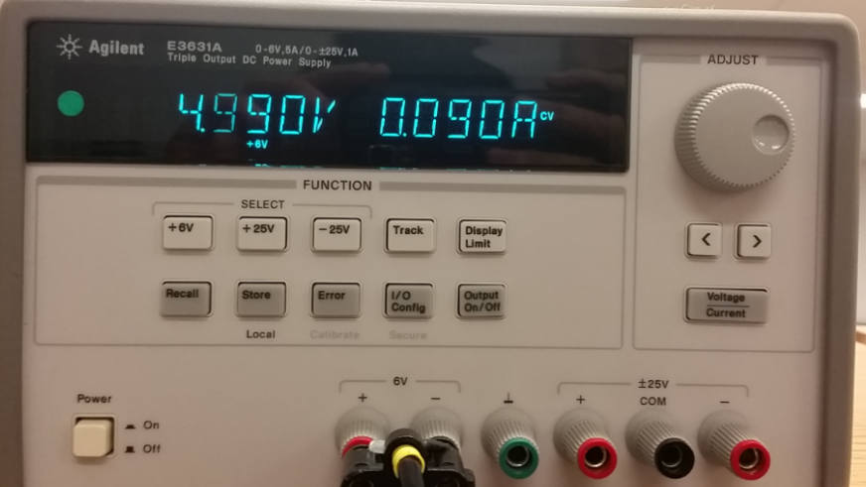

*Figure 4: about 90 mA was required to run the system* ***with*** *music playing*

*(this value did shoot up to 120-130 mA when playing louder music)*

1. **ANALYSIS AND DISCUSSION**
   1. **Briefly describe three errors in a DAC**

i) Offset Error: The difference between the DAC output and 0V when 0 is applied at the input.

ii) Full-scale Error: The difference between ideal and actual DAC output when max input is applied (very dependent on Vref stability).

iii) You could also not be sampling fast enough, have enough precision, or your sine wave table could not have enough values

* 1. **Calculate the data available and data required intervals in the SSI/DAC interface. Use these calculations to justify your choice of SSI frequency**
  2. **How is the frequency range of a spectrum analyzer determined?**
  3. **Why did we not simply drive the speaker directly from the DAC? What is the purpose of using the TPA731?**

We send a digital signal to the DAC that gets converted to a voltage level. But to power the speaker, we need current (which is why we use the amp). We also use the amp because 8ma of current from the TM4C is not enough to drive the speaker.